TEST CASES
Feature: ASL Learning Generation
Objective: Verify 4 ASLSign images and meanings are shown.
Preconiditions:
- database1 contains an array of 4 ASLSign’s. “A”,”B”,”C”, and “D” that are not unlocked.
- Unhandled input TEST_ACTION calls Handle_Interact(“NEWSPAPER”)
TestSteps:
- Start game
- Press shift+T
Expected Results: The screen should display 4 ASL signs to the player. Both their meaning and image should be shown
Actual Result:
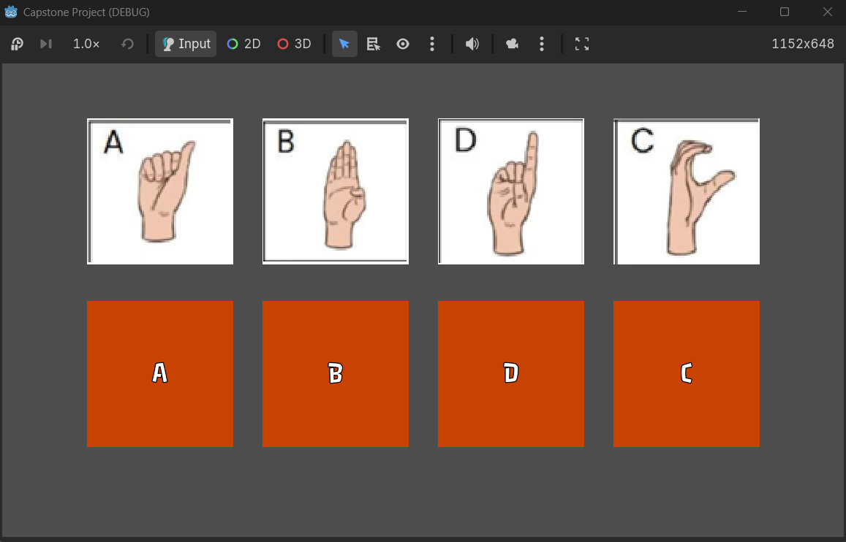
Status: PASS

Feature: ASL Quiz Generation
Objective: Verify 4 ASLSign images and meanings are shown and quiz cycles through different questions and question types.
Preconditions:
- database1 contains an array of 4 ASLSign’s. “A”,”B”,”C”, and “D” that are unlocked.
- Unhandled input TEST_ACTION calls Handle_Interact(“TREE1”)
TestSteps:
- Start game
- Press shift+T
- Answer questions displayed on screen until no questions are displayed
Expected Results: The screen should display either an image prompt with 4 meanings or a meaning prompt with 4 images. The player should be able to click on one of the 4 answers and the quiz should present a new question. This should be done 4 times, since this is the size of generated by CreateASLQuiz.
Actual Result:
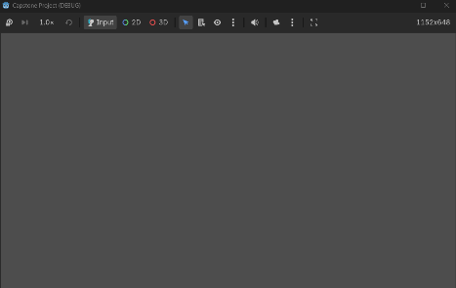
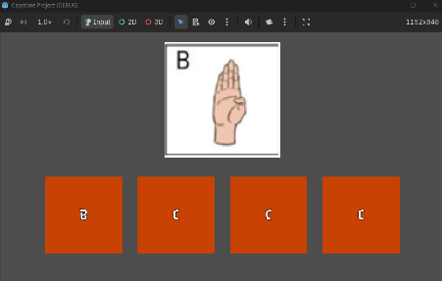
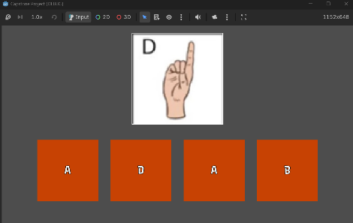

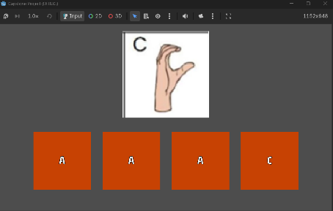
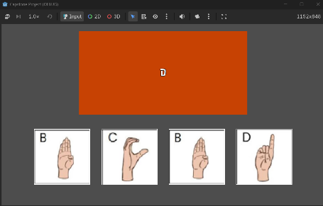

Status: PASS

